Warm-up Question:
What have you been thinking about lately?

Activity 1: Pair work

- How important are exercise, food, and sleep for mental health?

- Have you experienced insomnia? How well do you sleep?

- What gives you stress? How do you deal with that stress?
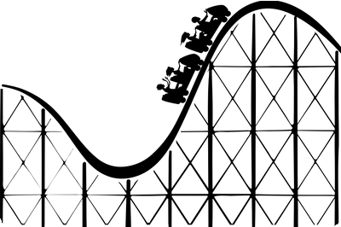
- The number of people who take anxiety medication increased during the coronavirus pandemic. Why do you think this is?
- People talk openly about some physical health issues, but they seem less comfortable talking about mental health issues. Why is this? Should it be this way?
- To perform at a high level, how important is mental strength?

- In Vietnam, what happens to people with serious psychological problems?

- What does it mean to be depressed?

- Which countries have the highest suicide rates? Why do you think they have those high rates?

Activity 2: Group discussion
Work in groups of 4-6.
Read the tips to improve your memory : Top 10 Tips To Improve Memory.pdf, then discuss the key tips which could enhance your memory:
- Explain your understanding of these tips (at least 3)
- Which types of methods do you find most interesting? Why & give examples?

Activity 3: Group discussion

Describe a way to improve your memory
You should say
• What it is
• What tools or equipment you need
• How often you use this way
and explain how your memory has been improved.

